Week In Review
Alex Shvartsman

PRO TOUR: CHICAGO
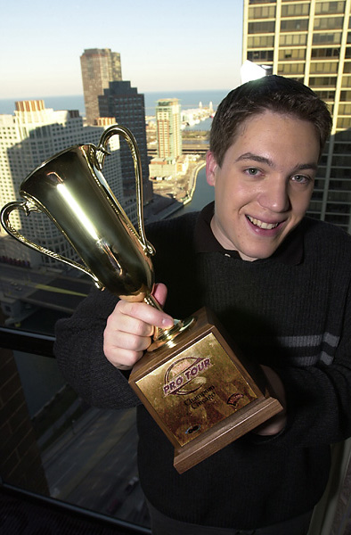
A type 2 Pro Tour finally took place in Chicago. The PT Chicago tradition of an unknown player winning the event was finally broken, as Kai Budde defeated Kamiel Cornellisen in the all-Rebel final match to become the third player ever to win three Pro Tours. Many other notables did well in this tournament. Brian Kibler and Jay Elarar finally achieved their first Pro Tour top 8, Zvi Mowhshowitz, Mike Pustilnik and Robert Dougherty all made top 8 for the second time and Jon Finkel surprised no one by also top 8'ing.
Pro Tour Chicago defined the type 2 metagame, suggesting that Fires (R/G Beatdown), Rebels, and Blue Skies (mono-U beatdown) are the top archetypes, closely followed by NetherGo, U/W control and W/G BlastoGeddon.
Detailed coverage of Pro Tour: Chicago may be found here.

CHICAGO MASTERS SERIES
While Pro Tour: Chicago was establishing the type 2 metagame, top 32 players in the world were busy competing in an Invasion Booster Draft format.
Competitors drafted and played two rounds on the first day, with the 8 winners advancing to do another draft on Friday and play out the matches during the course of the weekend.
Spectators and judges felt that the better deck lost in all four of the matches, with Bregoli, Williams, Luhrs and Maher all getting knocked out.
In the quarter finals Jon Finkel defeated me, while Ben Rubin beat Kyle Rose. The final match of this tournament would feature a re-match of the Magic Invitational in Sydney.
This time around it was Rubin's turn to shine. He defeated Finkel to become the second Masters winner ever. It is interesting that both Rubin and Jensen are parts of the same team - "Huey, Ben and Casey" that won Grand Prix: Pittsburgh earlier. Is it Casey McCarrel's turn to win the next Masters?
Full coverage of the Masters series can he found here.

COMING UP: GP SINGAPORE
Next weekend will see the last Grand Prix of the Extended season. None of the top American pros are expected to attend this one, but plenty of players from the region - including pros from Taiwan, Japan and Malaysia, are going to attend.
There are several interesting storylines to watch for during the Grand Prix coverage this weekend. Will Japanese players continue to dominate the Asian Grand Prix circuit, or will players from other parts of Asia do better this time? Can Tobey Tamber continue his streak of making top 8 in every Asian Grand Prix he participated in so far (he played in 3). Can Nick Wong, who was part of the winning team at Grand Prix: Nagoya, but failed to achieve an individual top 8 yet, succeed on home ground? Will a combo deck win yet another Grand Prix?

COMING UP: GRUDGE MATCH FINALS
Players in New York and Boston who managed to qualify for what has become a very prestigious tournament will compete in the type 2 format this weekend to determine which two players will defend the honor of their city in the one on one playoff.
Last time, a relatively unknown James Bradley from NYC defeated the notorious Tom Guevin to win the title for New York. This time it seems that Boston has a pretty strong group of players qualified for the finals. Who will advance to represent their home town? Check Neutral Ground and Your Move Games web sites for more details.

FINKEL'S NEW OPHIDIAN
During the Question Mark trivia contest at Pro Tour: Chicago, Mark Rosewater revealed the new card that Jon Finkel submitted for winning the Magic Invitational.
This new creature is 2/3 for 1UB that allows its controller to draw a card any time it deals damage to an opponent. Its activated abilities include become unblockable by non-black, non-artifact creatures for B, and untargetable for U.
I expect that should R&D actually print this card, they will likely add 5 or so to its casting cost.

TRADING TRENDS
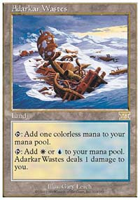
Chicago set the type 2 metagame, and now players will rush to trade for the cards they need to complete the winning decks. So what cards are going to go up in value for a while? Here is a short list:
Adarkar Wastes
Absorb
Armageddon
Birds of Paradise
Jade Leech
Lin Sivvi
Nether Spirit
Parallax Wave
Saproling Burst
Undermine

BEST OF THE NET
An interesting article on the effect of trashtalk on tournament play written by the level 3 judge and the head judge of the Chicago Masters Series Sheldon Menery can be found on Mindripper.
For those players who are into number-crunching, the same web site offers an analysis of how often a Demonic Consultation could, or should, go bad. Brett Allen's article can be found here.

PLAY OF THE WEEK
Shawn Keller faced Tom Guevin in one of the early rounds of Pro Tour: Chicago. With both players using control decks and the game score tied 1-1, it seemed the match would end in a draw since there was only a couple of minutes left on the clock by the time they were ready to begin game three.
Keller had other plans though. Instead of playing a land on his first turn, he chose to discard a Nether Spirit. On his next turn the Nether Spirit came into play, and he discarded another one, once again being forced not to play his first land.
These two 2/2 creatures proved too much to handle for Guevin's deck, which was sideboarded to best deal with control rather than creatures. Keller managed to snatch a victory from the jaws of a draw right before the time ran out.
Got a play of the week or another bit of information that should be printed in this column? Please e-mail me at ashv@concentric.net.

